2025 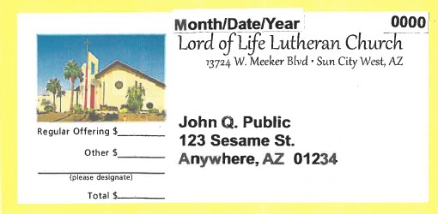
LOL MEMBER SUMMER ADDRESS CHANGE FORM

Why a Summer Address Change Form? This information helps us avoid mailed items going to the wrong address, thereby incurring extra postage charges. This includes the mailing of personalized giving envelopes, the Lifelines newsletter, and occasional member mailings.

More about Giving Envelopes: Providing 45 days or more notice allows for your address change to be implemented by our envelope company so your giving envelopes are mailed to your summer in a timely manner. (This also prevents unnecessary printing and postage charges.) Additionally, the date you plan to return to Arizona is just as important. Again, it requires 45 days advance notice to reverse the process so that you begin receiving your giving envelopes upon your return to Arizona.

So that the office can assist with the timely delivery of your envelopes to the address, please complete the information on the right side of this form as accurately as possible. Incomplete departure and return dates will cause mail delivery to be interrupted.

Please be assured, in the event your pre-printed envelopes have not reached you in time, you can always use a white My Gift envelope or a blank envelope with your name and Lord of Life Giving Number on it. Again, we assure you that your gift is recorded accurately even in the absence of pre-printed envelopes.

Questions? Contact the Church Office at 623-584-2000. Thank you for providing this information – have a safe and enjoyable summer!

Please complete the following information and place it in the offering plate, or return it to the Church Office:

YOUR INFORMATION:
NAME: ___________________________ GIVING #: ___________
Summer Address: _________________________________________
_________________________________________

What date are you LEAVING Arizona? ____________________
What date are you RETURNING to Arizona? ____________________
PLEASE NOTE: If your RETURN DATE is unknown, we will continue to mail to your summer address until you notify us that you have returned.

GIVING INFORMATION:
Do you give online or via electronic bill-pay? ___ Yes ___ No

If you answered “No” above and use personalized giving envelopes, do you want your GIVING ENVELOPES mailed to your summer address? Or suspended until you return?
__ Mail to summer address
__ Suspend until I return

NEWSLETTER INFORMATION:
Do you currently receive the LIFELINES NEWSLETTER via U.S. Mail?
___ Yes ___ No

If you answered “Yes” above, do you want the LIFELINES NEWSLETTER mailed to your summer address? Or suspended untl you return?
__ Maid to summer address
__ Suspend until I return

We can also email the newsletter to you if you prefer; if so, please provide your email address: ______________________________________________________

